Lake Jackson Ecosystem
Lake Jackson is a large shallow lake north of Tallahassee in Leon County, Florida. Lake Jackson experiences annual fluctuations in water level and partial or almost complete drydowns during periods of drought.
Musk Turtle

Lake Jackson is designated as a State Aquatic Preserve and an Outstanding Water Body, and is considered one of Leon County’s most precious natural resources. Lake Jackson supports populations of many species of fish, aquatic birds, mammals, reptiles and amphibians.

The Problem: Road Mortality
A wildlife mortality crisis is occurring at Lake Jackson on U. S. Highway 27, a road that bisects the lake. This road is a busy 4-lane divided highway with over 21,500 vehicles per day.
Normal annual fluctuations in water levels and periodic drydowns cause wildlife to attempt to migrate across this highway. To prevent turtles and other wildlife from being killed on this road, temporary nylon silt-fences were constructed to divert animals through a culvert under the road.
Turtles being redirected by temporary fence
In 33 months, over 8,600 turtles have been found attempting to cross the road at this site, the highest rate ever documented for any road mortality site in the world.
These fences were monitored from 2000-
2003 and 43 species of reptiles and amphibians and 15 species of mammals were documented attempting to cross or were found dead on the road.

Turtles and other wildlife play an important role in lake ecosystems by eating invasive species of plants like Hydrilla and scavenging on dead material. These animals maintain proper ecosystem functioning in Lake Jackson.
Wildlife on the highway is also a threat to motorist safety: large alligators, softshell and snapping turtles (up to 30 lbs.) frequently attempt to cross this road.

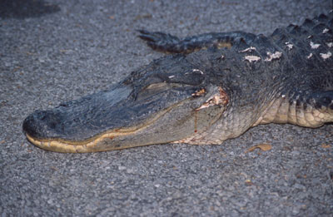
This 7-foot alligator was killed crossing US Highway 27

The Solution: An Ecopassage
To allow wildlife to continue their natural migration across this highway, a series of culverts and guidewalls can be constructed to allow these animals to pass unharmed under the road. The ecopassage below was recently constructed by the Florida Department of Transportation at Payne’s Prairie on
U. S. 441 near Gainesville.

The benefits of the ecopassage are that wildlife mortality would be greatly reduced, wildlife movement patterns would be restored to their natural state, and motorist safety would be improved.

This softshell turtle was injured while trying to cross the road. An ecopassage at this site would prevent future mortality and injury to many species of wildlife.

How You Can Help:
Public support of the Lake Jackson Ecopassage is critical to convincing local and state officials to complete this project. You can help by writing letters of support for the ecopassage to the officials listed on our website.
The Lake Jackson Ecopassage Alliance maintains the temporary fences, works with government officials, and increases public awareness about this issue. We are funded solely through donations from our supporters.
For more information please contact us at the address listed on the front of this brochure and visit our website:
www.lakejacksonturtles.org
Lake Jackson Ecopassage Alliance
P. O. Box 180891
Tallahassee, Florida 32318
All donations receive a bumper sticker!

www.lakejacksonturtles.org

The
Lake Jackson Ecopassage
Providing a Safe Path for Wildlife

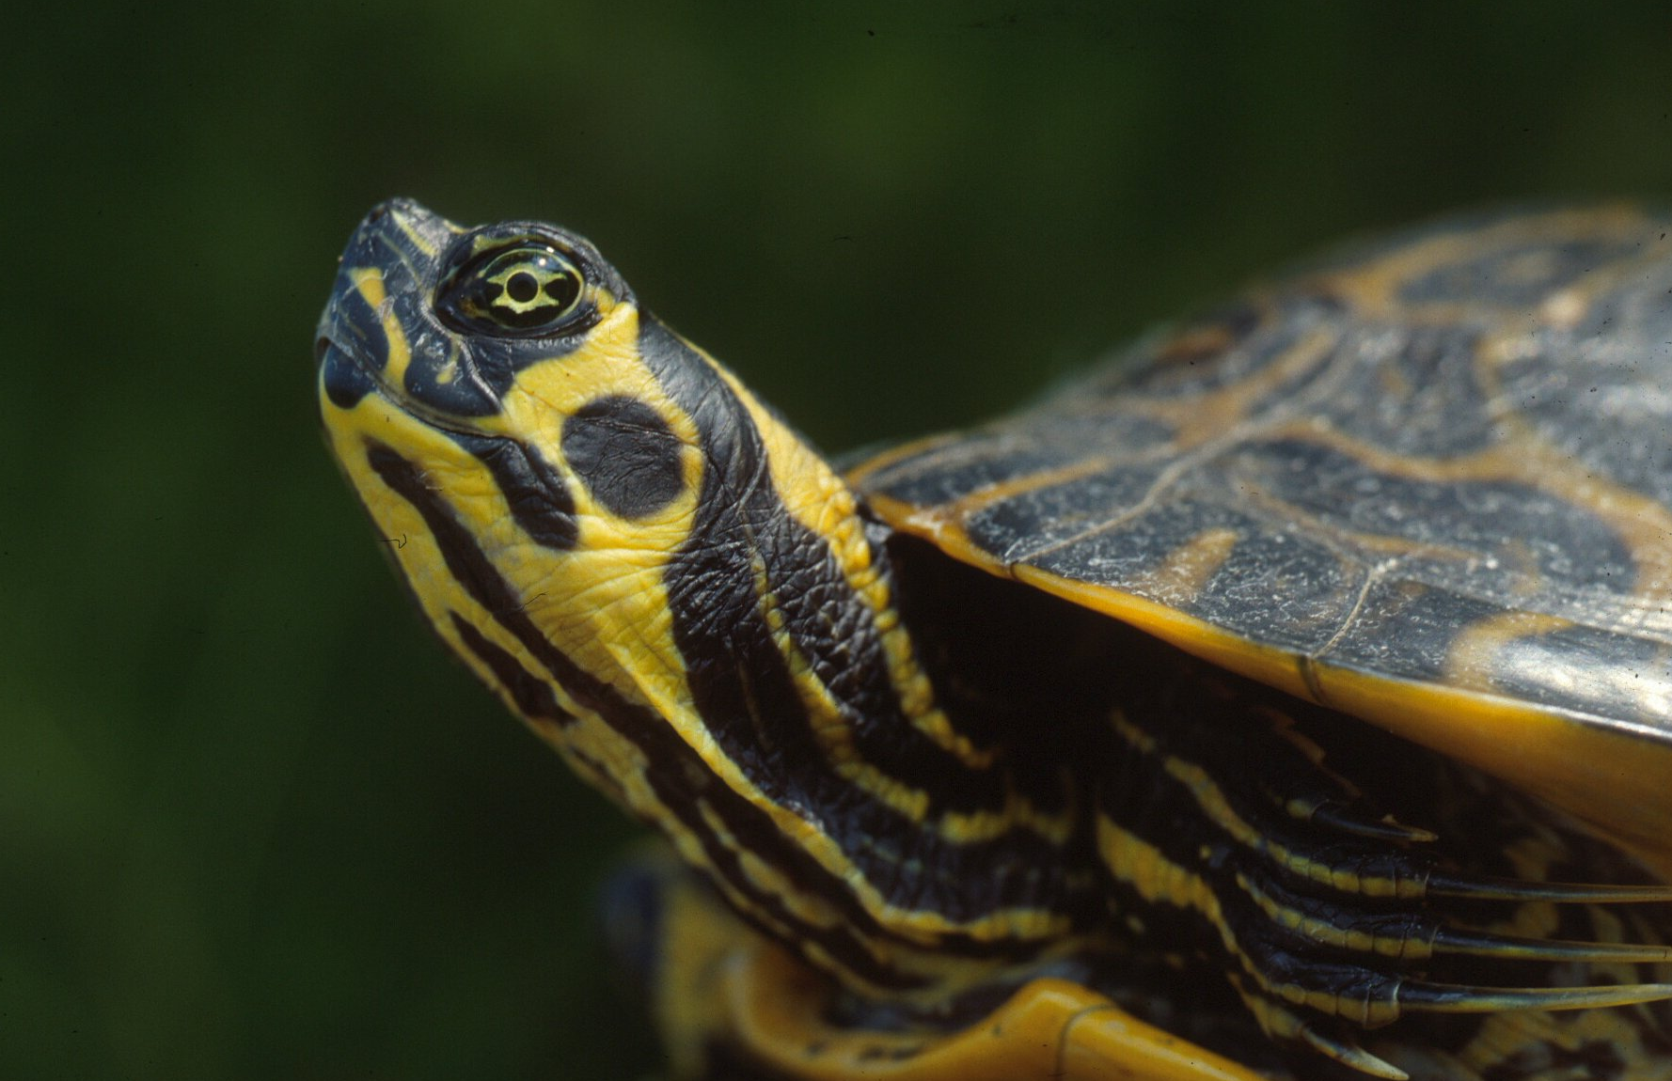
Florida Cooter

Pig Frog

Lake Jackson Ecopassage Alliance
P. O. Box 180891
Tallahassee, FL 32318

Phone: (850) 562-3093
turtles@lakejacksonturtles.org
www.lakejacksonturtles.org

