Help Save Lake Jackson's Turtles
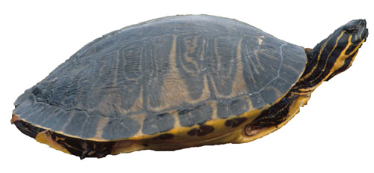  Florida cooter | Support the  Lake Jackson Ecopassage | 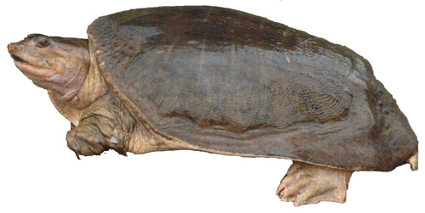  Florida softshell

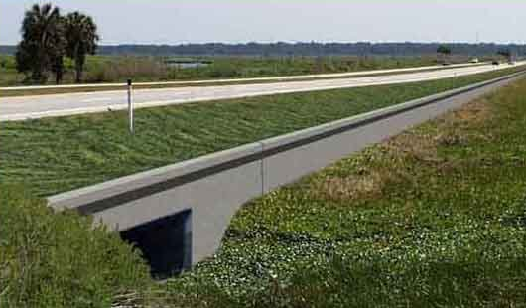 Lake Jackson is bisected by US Highway 27, which forms an impassable barrier to turtles, frogs, snakes, and other wildlife that attempt to migrate between the two sections of the lake. Over 8,500 individual turtles have been documented attempting to migrate across US 27 at this site. A temporary fence has saved many of these turtles, but public support is needed to convince government officials to construct a permanent ecopassage.
The Solution: A permanent guide-wall and culvert ecopassage
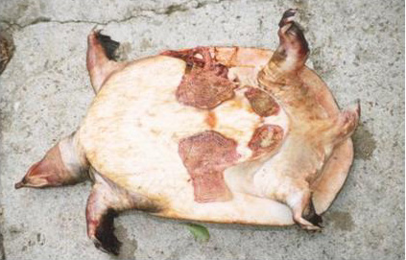
Proposed Ecopassage design
The Problem: Highest rate of road-killed turtles in North America
Dead Florida softshell turtle

The following website provides much more information about this project:
http://www.lakejacksonturtles.org

Please send letters urging these officials to support construction of a permanent ecopassage for US Highway 27 at Lake Jackson, Leon Co., Florida:
Leon County Board of County Commissioners  Leon Co. Courthouse, 301 S. Monroe Street  Tallahassee, FL 32301-1853 | The Honorable Bob Graham, US Senator  2252 Killearn Center Blvd, Suite 300 Tallahassee, FL 32309
Jack Kostrzewa (liaison for FDOT)  Tallahassee-Leon County Planning Department  City Hall, 300 S. Adams Street  Tallahassee, FL 32301 | The Honorable Alfred Lawson, Jr., Senator Room 210, Senate Office Building  404 S. Monroe St.  Tallahassee, FL 32399-1100
The Honorable Loranne Ausley, Representative  Room 801, The Capitol  402 S. Monroe St.  Tallahassee, FL 32399-1300 | The Honorable Curtis Richardson, Representative  Room 1003, The Capitol  402 S. Monroe St.  Tallahassee, FL 32399-1300
For more information about this project, please contact:
Lake Jackson Ecopassage Alliance, P.O. Box 180891, Tallahassee, Florida, 32318
Email: turtles@lakejacksonturtles.org Phone: (850) 562-3093 Fax: (850) 644-9829

